JVI/ICD Webinar – September 8, 2022
Presenters

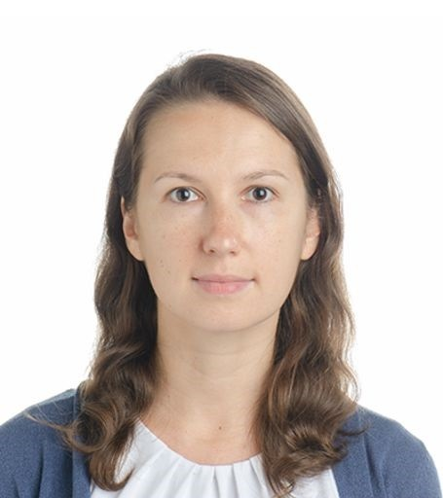 | Natalia Malysheva is a Capacity Development Officer in IMF’s Institute for Capacity Development, where she serves as a project manager for the development of online courses and blended deliveries, oversees the online learning delivery program, and contributes to the coordination of the overall IMF Institute Training Program.
 | Verónica Sánchez, of Chilean nationality, is a Project Manager at the Institute for Capacity Development, where she manages courses translations into languages other than English and the online learning program communications. Previously, she was a project manager at the Inter-American Development Bank (IDB), producing online courses; and a communications officer at the Deutsche Schule Concepción in Chile.

